|  |
| --- |
| IOWA |
| Sebastian Beck  PJG511 |
| 4/12-2019 |

Index

Introduction 3

Method 3

Materials 3

Test procedure 3

Results 4

Significant differences between the two sessions 4

Session 1 is for leaning, session 2 is for earning 5

Age doesn’t bring caution 7

Conclusion 7

References 8

# Introduction

In everyday life each person makes many decisions, often these decisions are made on insufficient grounding. In such situations we must rely on our gut feeling or intuition. This gut feeling has been investigated through the somatic marker hypothesis (Bechara, Damasio, Damasio, & Anderson, 1994). This hypothesis states that the ventromedial prefrontal cortex contains an index, which links factual knowledge and bioregulatory states associated with a particular event (Purves et al., 2013). These somatic markers include autonomic, endocrine and musculoskeletal changes that constitutes an emotional state. Any time we are placed in a similar event, our prior knowledge reactivates the same somatic markers, which in turn help guide decision making by indicating whether what we did last time was associated as either a positive or negative outcome. This hypothesis was tested through the Iowa Gambling Task experiment (Bechara et al., 1994). The present study is a repetition of the original paradigm. We hypothesize that the final capital is larger after the second trial, and that more draws has been done from the safe decks than the unsafe decks.

Prior studies have shown that risk taking are influenced by age (Purves et al., 2013). They have shown that younger persons are more prone to taking risks than older persons. We investigate whether the same can be found in the present study.

Lastly, we investigate if the highest scores in the first session, are due to the participants figuring out the reward/punishment ratios early on or if it is due to luck. If it is due to figuring out the ratios, we would expect the same participants to score high in the second test.

# Method

This experiment included *N* = 203 participants, all psychology students at UCPH.

## Materials

* E-Prime® experiment file containing IOWA gambling task
* Headphones
* Questionnaire for estimating reward/punishment ratio and sizes

## Test procedure

Present during the experiment was only the participant (P). Before the experiment started, P was instructed to plug in the headphones and test the volume on the computer. When ready, P opened the file containing the experiment and instructions. The object of the game is to earn as much money as possible by drawing cards from four decks. P was at liberty to choose any card at any time. Each deck had different reward/punishment ratios. When a card was revealed, one of three sounds were played: one for rewards above 50dkk, one for rewards below 50dkk and one for when a punishment occurs. The length of the punishment sound was matched to the size of punishment. P was naïve as to the number of draws in the experiment. After 100 draws the first experiment ended. P answered the questionnaire about the experienced reward/punishment ratio and sizes for each deck. The experiment was run twice per P.

# Results

## Significant differences between the two sessions

|  |  |  |  |  |  |  |  |  |  |  |  |  |  |  |
| --- | --- | --- | --- | --- | --- | --- | --- | --- | --- | --- | --- | --- | --- | --- |
| Table 1:  *Mean share of draws from decks A&B vs C&D, and end capital* | | | | | | | | | | | | | | |
|  |  | *M* |  | *SD* |  | *M* |  | *SD* |  | *t*-tests | | | | |
|  |  | Deck A & B | | |  | Deck C & D | | |  | *t*(202) |  | *p* |  | *d* |
| Session 1 |  | 0.43 |  | (0.13) |  | 0.57 |  | (0.13) |  | 7.33 |  | < .001 |  | 1.03 |
| Session 2 |  | 0.30 |  | (0.16) |  | 0.70 |  | (0.16) |  | 17.99 |  | < .001 |  | 2.53 |
|  | | | | | | | | | | | | | | |
|  |  | Session 1 | | |  | Session 2 | | |  | *t*(202) |  | *p* |  | *d* |
| End Capital |  | 1999.88 |  | 866.07 |  | 2956.65 |  | 1291.11 |  | 9.89 |  | < .001 |  | 0.89 |
| *Note: Values for deck-variables are displayed as mean share of total draws for each session. End capital shows the mean capital in DKK at the end of each session*. | | | | | | | | | | | | | | |

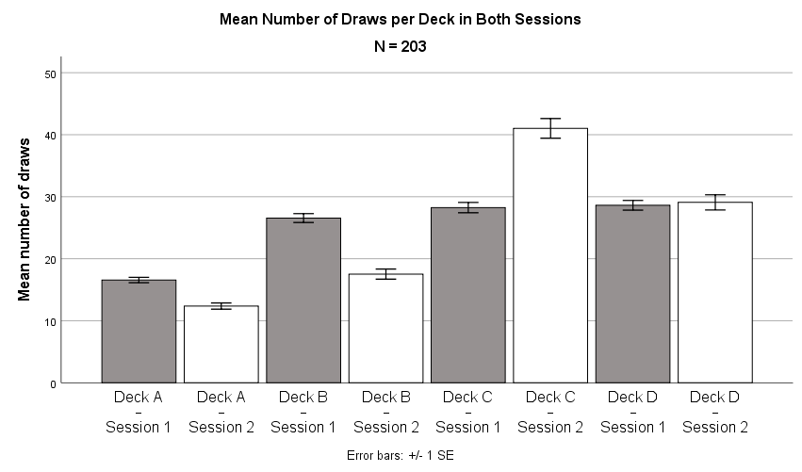

Figure 1: Shows the mean no. of draws for each deck for each session.

Figure 1 shows the distribution of draws per deck, for each of the two sessions. In each of the sessions, the unfavourable decks (A and B) was chosen less than the favourable decks (C and D), This was more profound in session 2. A repeated measures ANOVA was used to test whether this effect was significant. The test showed a significant main effect of deck on number of draws, *F*(1.96, 396.68) = 94.38, *p* < .001, $η_{p}^{2}$ = .32 (Huyhn-Feldt corrected), and a significant interaction between session and deck, *F*(1.94, 392.26) = 61.94, *p* < .001, $η_{p}^{2}$ = .24 (Huyhn-Feldt corrected), but no significant main effect of session, *F*(1, 202) = 1.00, *p* = .32, $η_{p}^{2}$ = .01.

If no learning had occurred, we would have expected an equal number of draws from each deck. The main effect of deck on number of draws, suggests that P already were favouring some decks in session 1. The interaction between session and deck shows that different decks were chosen in session 1 and 2. This is supported by table 1 as well, which shows that deck C and D were already favoured in session 1, but this was even more the case in session 2. All this supports the somatic marker hypothesis.

## Session 1 is for leaning, session 2 is for earning

In learning the reward/punishment ratio of each deck, we expect P to make an equal amount of draws from each deck. This evens out the rewards and punishments and therefore result in no significant overall earnings. When the favourable decks were determined in session 1, we would expect more of these to be chosen in session 2 and to see a significant earning. A One sample *t*-tests (two-tailed, α = .05) was used to tests this, and showed a significant difference from 2000 DKK in end capital (*M* = 2956.65, *SD* = 1291.11) for session 2, *t*(202) = 10.56, *p* < .001, *d* = 0.00, but no significant difference from 2000 DKK in end capital (*M* = 1999.88, *SD* = 866.07) for session 1, *t*(202) = -0.002, *p* = .998, *d* = 0.74. Which confirms the hypothesis.

Figure 2 and 3 shows an example of how learning can be seen between sessions. In figure 2 we see an equal amount of draws from each deck until draw number 38. Following a great punishment, we see that this P instantly changes strategy and focusing only on the safe decks.

Figure 2: Graph showing capital size and choice of deck, as a function of number of draws in session 1 for FP19203.

Figure 3 shows how this is transferred into session 2. Here FP19203 focuses on the two high reward decks, until the first punishment occurs, hereafter practically only deck C is chosen. This yields a greater outcome.

Figure 3: Graph showing capital size and choice of deck, as a function of number of draws in session 2 for FP19203.

As exampled by FP19203, some P seem to have figured out the reward/punishment ratios rather early, and therefore end up having a higher final score as well. If this is the result of learning, we expect the same P to have a higher score in session 2 as well. In order to test this, a two-tailed Pearson’s correlation was used. This showed a significant positive correlation between end capital for session 1 and end capital for session 2, *r*(201) = .23, *p* < .001. Which means that P doing well in session 1, does equally well in session 2. This supports the hypothesis.

## Age doesn’t bring caution

To test whether younger P were more prone to risk-taking a two-tailed Pearson’s correlation was used. This showed no significant correlation between age and end capital for session 2, *r*(201) = .04, *p* = .60. Age didn’t correlate with capital, which doesn’t support the hypothesis.

# Conclusion

This experiment showed that intuitive learning did occur between session 1 and 2, and that P who did well in session 1 didn’t do so by chance, since they also did well in session 2. Lastly our experiment didn’t support the hypothesis that with age comes caution.

# References

Bechara, A., Damasio, A. R., Damasio, H., & Anderson, S. W. (1994). Insensitivity to future consequences following damage to human prefrontal cortex. *Cognition*, *50*, 7–15.

Purves, D., Cabeza, R., Huettel, S. A., LaBar, K. S., Platt, M. L., & Woldorff, M. G. (2013). *Principles of Cognitive Neuroscience* (2nd ed.). Sunderland, Massachusetts: Sinauer Associates, Inc., Publishers.